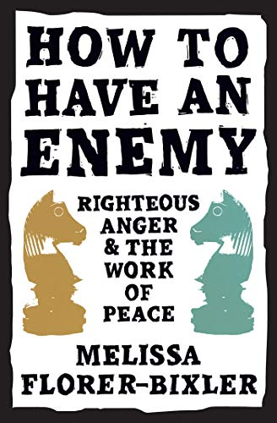
Capitalism and Racism, Goerzen Home Study Group, March27, 2022
NOTE: April 23, 2022 We have been studying an excellent book in this discussion group: How to Have an Enemy: Righteous Anger and the Work of Peace, by Melissa Florer-Bixler. When we discussed Chapter 10: “Becoming Enemies of Mammon,”
as part of an assigned task to four of us, I prepared the following. Not a paper, but extraction from a wide range of voices, that I thought worth sharing. Please read on.
You may also find this on my website:
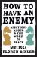
Capitalism and Racism
March 28, 2022

All book titles are clickable.
- “Only the United Kingdom has beaten our record for square miles of territory acquired by military conquest. Our exploits against the American Indian, against the Filipinos, the Mexicans, and against Spain are on a par with the campaigns of Genghis Khan, the Japanese in Manchuria and the African attack of Mussolini.”—Smedley Butler

- “. . . without English capitalism there probably would have been no capitalis[t] system of any kind.”—anonymous

- “. . . the rulers of the British Empire will one day be perceived to rank with the dictators of the twentieth century as the authors of crimes against humanity on an infamous scale.”— Richard Gott. Of course, a friendly amendment would also include their brethren in North America in this hall of infamous shame. Indeed, the forces unleashed by the rise of London, then New York, proved little less than apocalyptic for Africans and the indigenous of North America.— Gerald Horne

- “The former apartheid cabinet member Leon Wessels was closer to the mark when he said that they had not wanted to know, for there were those who tried to alert them.”— Desmond Tutu

- “Aber haben Sie nicht gewußt?” [But didn’t you know (about the disappeared Jews in Nazi Germany?)] Their voices responded: “Nein.” But their eyes said: “Ja.”—Wayne Northey in West Berlin, 1972-1974

- “The world cannot, for long, endure the truth—‘humankind cannot bear much reality,’ as T.S. Eliot says—and the truth cannot, for long, endure in the world.”—David Cayley, citing Ivan Illich

- Woe to you, scribes and Pharisees, you hypocrites! You build tombs for the prophets and decorate the monuments of the righteous. And you say, ‘If we had lived in the days of our fathers, we would not have been partners with them in shedding the blood of the prophets.’ So you testify against yourselves that you are the sons of those who murdered the prophets. Fill up, then, the measure of the sin of your fathers. You snakes! You brood of vipers! How will you escape the sentence of hell?—Jesus

- “The line separating good and evil passes not through states, nor between classes, nor between political parties either -- but right through every human heart -- and through all human hearts. This line shifts. Inside us, it oscillates with the years. And even within hearts overwhelmed by evil, one small bridgehead of good is retained.”— Aleksandr Solzhenitsyn
When they continued to question Him, He straightened up and said to them, “Let him who is without sin among you be the first to cast a stone at her.” And again He bent down and wrote on the ground.—John 8
A Little Bit of History
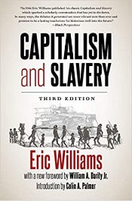
Eric Williams, Capitalism and Slavery, Lulu.com. Kindle Edition.

… slavery was an economic institution of the first importance. It had been the basis of Greek economy and had built up the Roman Empire. In modern times it provided the sugar for the tea and the coffee cups of the Western world. It produced the cotton to serve as a base for modern capitalism. It made the American South and the Caribbean islands. Seen in historical perspective, it forms a part of that general picture of the harsh treatment of the underprivileged classes, the unsympathetic poor laws and severe feudal laws, and the indifference with which the rising capitalist class was “beginning to reckon prosperity in terms of pounds sterling, and . . . becoming used to the idea of sacrificing human life to the deity of increased production.”

The reasons for slavery, wrote Edward Gibbon Wakefield, “are not moral, but economical circumstances; they relate not to vice and virtue, but to production.” With the limited population of Europe in the sixteenth century, the free laborers necessary to cultivate the staple crops of sugar, tobacco and cotton in the New World could not have been supplied in quantities adequate to permit large-scale production. Slavery was necessary for this, and to get slaves the Europeans turned first to the aborigines and then to Africa.

Slavery was not born of racism: rather, racism was the consequence of slavery. Unfree labor in the New World was brown, white, black, and yellow; Catholic, Protestant and pagan.
Finally, and this was the decisive factor, the Negro slave was cheaper. The money which procured a white man’s services for ten years could buy a Negro for life.

Here, then, is the origin of Negro slavery. The reason was economic, not racial; it had to do not with the color of the laborer, but the cheapness of the labor.

Negro slavery’s … origin can be expressed in three words: in the Caribbean, Sugar; on the mainland, Tobacco and Cotton. A change in the economic structure produced a corresponding change in the labor supply. The fundamental fact was “the creation of an inferior social and economic organization of exploiters and exploited.”

See too my post:
- 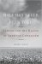
Slavery and the Making of American Capitalism
August 30, 2016
I write:

The Half Has Never Been Told: Slavery and the Making of American Capitalism, by Edward E. Baptist, connects the dots meticulously between the rise to world dominance of American Capitalism, and slavery as single most driving engine, that, in Trump’s ridiculous notion “made America great.” The review (an excerpt below with a link) makes us aware of the overwhelming horror (America’s “greatness” alright!) committed against Blacks over generations. White America cashed in on that horror, slavery being the single most contributing phenomenon to White America’s obscenely ill-gotten wealth. This is why it is almost impossible for the vast majority of Blacks to rise above the trauma effects of that horror to this day, let alone catch up economically. In response, one could shout from the housetops: BLACK LIVES MATTER!

This video—The head start in the race of life—is particularly telling:

Economic Factors

The Average Black Family Would Need 228 Years to Build the Wealth of a White Family Today, by Joshua Holland, August 9, 2016.

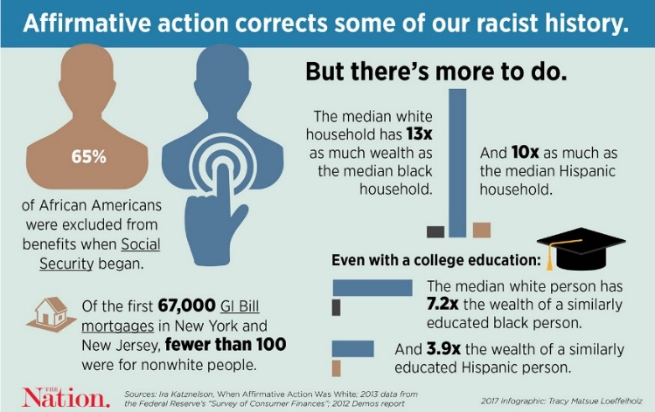
One reads:

If current economic trends continue, the average black household will need 228 years to accumulate as much wealth as their white counterparts hold today. For the average Latino family, it will take 84 years. Absent significant policy interventions, or a seismic change in the American economy, people of color will never close the gap.
Those are the key findings of a new study of the racial wealth-gap released this week by the Institute for Policy Studies (IPS) and the Corporation For Enterprise Development (CFED). They looked at trends in household wealth from 1983 to 2013—a 30-year period that captured the rise of Reaganomics, expanded international trade and two major financial crashes fueled by bubbles in the tech sector and housing prices. The authors found that the average wealth of white households increased by 84 percent during those three decades, three times the gains African-American families saw and 1.2 times the rate of growth for Latino families.
To put that in perspective, the wealthiest Americans—members of the Forbes 400 list—saw their net worths increase by 736 percent during that period, on average.
If those trends persist for another 30 years, the average white family’s net worth will grow by $18,000 per year, but black and Hispanic households would only see theirs grow by $750 and $2,250 per year, respectively.
“[Economist] Thomas Picketty said that, left uninterrupted, we would move toward a hereditary aristocracy of wealth,” says Chuck Collins, one of the study’s authors. “What he didn’t say is that in the United States, that would be almost entirely a white aristocracy of wealth.”
…
A truly perverse aspect of this story is that just as past public policies created the racial wealth gap, current policy continues to widen it. The federal government spends a fortune subsidizing wealth-building activities like paying for college, saving for retirement or buying a home, but most of those dollars go to people who already have wealth. Since 1994, government spending on wealth-building has more than tripled—from $200 billion in 1994 to $660 billion last year—according to the IPS/CFED study. The costliest of those subsidies is the home-mortgage tax deduction, and a 2013 study by the National Priorities Project found that 77 percent of those benefits go to households with annual incomes between $75,000 and $500,000. Similarly, an estimated two-thirds of all public subsidies for retirement savings go to those with incomes in the top 20 percent of the distribution. We’re spending a fortune on wealth building, but very little of it ends up bolstering the net worths of poor people and people of color.
The 17th Century Set the Course in the Western World
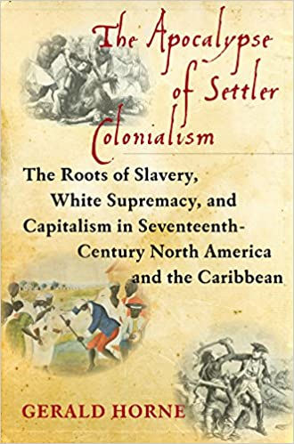
The Apocalypse of Settler Colonialism: The Roots of Slavery, White Supremacy, and Capitalism in 17th Century North America and the Caribbean—Gerald Horne

This is a book about the events in the seventeenth century that led to the creation of what is now called the modern and advanced world. It concerns the roots of slavery, white supremacy, and the ultimate expression of the two: capitalism.

. . . genocide [of American Indians]—in virtually every meaning of the term, including volitional acts by invading settlers—is the proximate cause of this towering mountain of cadavers.—Population may have fallen by up to 90 percent through . . . warfare, famine, and slavery, all with resultant epidemics. The majority of the enslaved were women and children, an obvious precursor, and trailblazer, for the sex trafficking of today.

What is euphemistically referred to as “modernity” is marked with the indelible stain of what might be termed the Three Horsemen of the Apocalypse: Slavery, White Supremacy, and Capitalism, with the bloody process of human bondage being the driving and animating force of this abject horror. . . The slave trade left the infirm and elderly behind—and took the rest. Systems of agriculture, mining, production of metal, cotton, wood, straw, clay and leather goods, trade, transport, and governance that had evolved over centuries were wounded severely. Community was turned against community, neighbor against neighbor. Simultaneously, the agents of this apocalypse profited handsomely.

As scholar William Pettigrew has argued forcefully, the African Slave Trade rested at the heart of what is still held dear in capitalist societies: free trade, anti-monarchism, and a racially sharpened and class-based democracy.

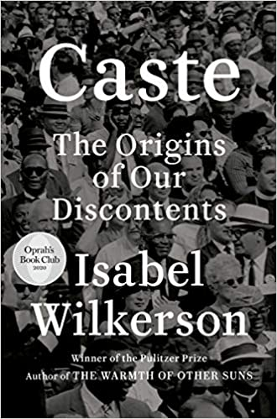
The classic book on this is: Caste: The Origins of Our Discontents, by Isabel Wilkerson.

We read of it:

Linking the caste systems of America, India, and Nazi Germany, Wilkerson explores eight pillars that underlie caste systems across civilizations, including divine will, bloodlines, stigma, and more. . . She documents how the Nazis studied the racial systems in America to plan their out-cast of the Jews; she discusses why the cruel logic of caste requires that there be a bottom rung for those in the middle to measure themselves against; she writes about the surprising health costs of caste, in depression and life expectancy, and the effects of this hierarchy on our culture and politics. Finally, she points forward to ways America can move beyond the artificial and destructive separations of human divisions, toward hope in our common humanity.

. . . as the filthy wealth generated by slavery and dispossession accelerated, capitalism and profit became the new god, with its curia in the basilicas of Wall Street. This new religion had its own doctrine and theologies, with the logic of the market and its “efficient market theory” supplanting papal infallibility as the new North Star.

As one scholar put it, “the industrial revolution in England and the cotton plantation in the South were part of the same set of facts.” (The only friendly amendment to this aphorism would be to include the 17th century so-called “sugar boom” as an antecedent of both.) More to the point, as yet another wise writer put it, “without English capitalism there probably would have been no capitalis[t] system of any kind.” As early as 1663, an observer in Surinam noticed that “Negroes [are] the strength and sinews of the Western world.” The enslaved, a peculiar form of capital encased in labor, represented simultaneously the barbarism of the emerging capitalism, along with its productive force.

ENSLAVED AFRICANS CONSTITUTED two-thirds of the total migration into the Americas between 1600 and 1700.

These forced migrants can be viewed, metaphorically and actually, as currency, helping to enrich certain Englishmen, aiding their nation’s rise from second-class status to global empire. Their arrival in the Americas represented a horrific leap for constructions of “race” that can be said to precede this bloody century.
Thus, 1776 completed the apocalypse begun in the seventeenth century. The British scholar Richard Gott has a point when he concludes that “the rulers of the British Empire will one day be perceived to rank with the dictators of the twentieth century as the authors of crimes against humanity on an infamous scale.” Of course, a friendly amendment would also include their brethren in North America in this hall of infamous shame. Indeed, the forces unleashed by the rise of London, then New York, proved little less than apocalyptic for Africans and the indigenous of North America.

In North America the colonialism implanted bloodily involved racialization, which meant the denial of the right to have rights, making millions—Africans particularly—denizens of a society but not of it, that is, permanent aliens, a status that has not entirely dissipated to this very day, indicating its profundity. [We of course rightly call this apartheid.] Ultimately, this is a description of what “race” means, a pernicious concept that emerged forcefully, coincidentally enough, in the seventeenth century as colonialism was gaining traction.

. . . with the Treaty of Westphalia of 1648, London was poised to yoke what had been a present though not dominant trend—slavery—to an ascending capitalism, converting societies with slaves to slave societies. This process took hold most notably in North America, then the United States of America.

IN SUM, THE SEVENTEENTH CENTURY is critical to comprehension of the rise of capitalism and the companion rise of London, then New York.

So: Is Capitalism Racist?

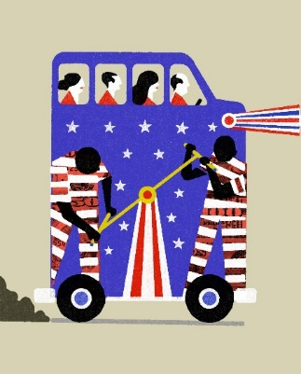
Is Captalism Racist?—by Nicholas Lemann, May 18, 2020
“There was no such thing as capitalism without slavery: the history of Manchester never happened without the history of Mississippi.”
The new history of slavery seeks to obliterate the economic and moral distinction between slavery and capitalism, and between the South and the North, by showing them to have been all part of a single system.…
§§§

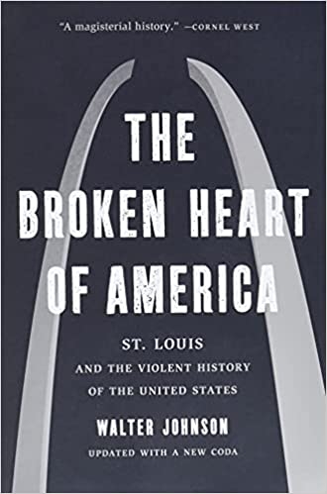
Walter Johnson in his new book, The Broken Heart of America: St. Louis and the Violent History of the United States is guided by the concept of] “racial capitalism”:

. . . racism as a technique for exploiting black people and for fomenting the hostility of working-class whites toward blacks, so as to enable white capitalists to extract value from everyone else. For his purposes, St. Louis is a case study in the pervasiveness and the longevity of racism outside the formal boundaries of slavery. As he wrote in an earlier essay,

The history of racial capitalism, it must be emphasized, is a history of wages as well as whips, of factories as well as plantations, of whiteness as well as blackness, of ‘freedom’ as well as slavery.

Racial capitalists conquered the West; racial capitalists waged the Civil War; racial capitalists industrialized St. Louis, and then deindustrialized it, at every step exploiting black people just as brutally as slaveholders did.

§§§

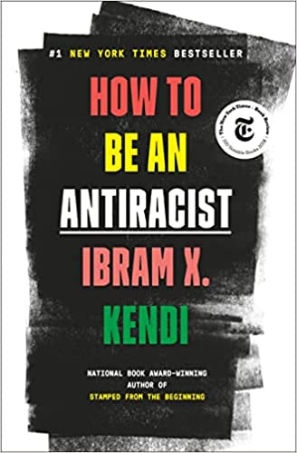
Antiracism is a transformative concept that reorients and reenergizes the conversation about racism—and, even more fundamentally, points us toward liberating new ways of thinking about ourselves and each other. At its core, racism is a powerful system that creates false hierarchies of human value; its warped logic extends beyond race, from the way we regard people of different ethnicities or skin colors to the way we treat people of different sexes, gender identities, and body types. Racism intersects with class and culture and geography and even changes the way we see and value ourselves. In How to Be an Antiracist, Ibram X. Kendi takes readers through a widening circle of antiracist ideas—from the most basic concepts to visionary possibilities—that will help readers see all forms of racism clearly, understand their poisonous consequences, and work to oppose them in our systems and in ourselves.
Kendi weaves an electrifying combination of ethics, history, law, and science with his own personal story of awakening to antiracism. This is an essential work for anyone who wants to go beyond the awareness of racism to the next step: contributing to the formation of a just and equitable society.

British/American Empires With Their Armies, Air Forces, Navies and Gangsterism/Crimes Against Humanity

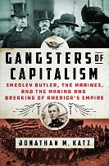
War is a Racket: The Antiwar Classic by America’s Most Decorated Soldier—General Smedley Butler

Gangsters of Capitalism: Smedley Butler, the Marines, and the Making and Breaking of America’s Empire—by Jonathan M. Katz

Smedley Butler was the most celebrated warfighter of his time. Best-selling books were written about him. Hollywood adored him. Wherever the flag went, “The Fighting Quaker” went - serving in nearly every major overseas conflict from the Spanish War of 1898 until the eve of World War II. From his first days as a 16-year-old recruit at the newly seized Guantánamo Bay, he blazed a path for empire: helping annex the Philippines and the land for the Panama Canal, leading troops in China (twice), and helping invade and occupy Nicaragua, Puerto Rico, Haiti, Mexico, and more.

Yet in retirement, Butler turned into a warrior against war, imperialism, and big business, declaring: “I spent most of my time being a high-class muscle man for big business, for Wall Street and for the bankers. In short, I was a racketeer for capitalism.”
That tension—between the ideal of the United States as a leading champion of democracy on the one hand and a leading destroyer of democracy on the other—remains the often unacknowledged fault line running through American politics today.

§§§

“What is fascism but colonialism in the heart of a traditionally colonialist country?”— Frantz Fanon, French West Indian psychiatrist and political philosopher from the French colony of Martinique

§§§

“Only the United Kingdom has beaten our record for square miles of territory acquired by military conquest. Our exploits against the American Indian, against the Filipinos, the Mexicans, and against Spain are on a par with the campaigns of Genghis Khan, the Japanese in Manchuria and the African attack of Mussolini.”—Smedley Butler

§§§

Between 1960, by which time the Soviets had dismantled Stalin’s gulags, and the Soviet collapse in 1990, the numbers of political prisoners, torture victims, and executions of nonviolent political dissenters in Latin America vastly exceeded those of the Soviet Union and its East European satellites. In other words, from 1960 to 1990, the Soviet bloc as a whole was less repressive, measured in terms of human victims, than many individual Latin American countries [under direct sway of US Empire].—John Coatsworth in The Cambridge History of the Cold War

Donald Trump preyed on American anxieties by combining the worst excesses of those early-twentieth-century imperial chestnuts—militarism, white supremacy, and the cult of manhood—with a newer fantasy: that Americans could reclaim our sense of safety and supremacy by disengaging from the world we made; by literally building walls along our border and making the countries we conquered pay for them. To those who did not know or ignored America’s imperial history, it could seem that Trump was an alien force (“this is not who we are,” as the liberal saying goes), or that the implosion of his presidency has made it safe to slip back into comfortable amnesias. But the movement Trump built—a movement that stormed the Capitol, tried to overturn an election, and as I write these words still dreams of reinstalling him by force—is too firmly rooted in America’s past to be dislodged without substantial effort. It is a product of the greed, bigotry, and denialism that were woven into the structure of U.S. global supremacy from the beginning—forces that now threaten to break apart not only the empire but the society that birthed it.

§§§

Empire’s Religion: Arundhati Roy Confronts the Tyranny of the Free Market, by Jake Johnson, September 15, 2016. See: Arundhati Roy.

“The hidden hand of the market,” Friedman notes in a particularly telling fragment, “will never work without a hidden fist. McDonald’s cannot flourish without McDonnell Douglass, the designer of the F-15. And the hidden fist that keeps the world safe for Silicon Valley’s technologies to flourish is called the U.S. Army, Air Force, Navy, and Marine Corps.”

Nowhere is this more obvious than in The End of Imagination, a collection of Roy’s essays released earlier this month. Ever-present—whether stated outright or in narrative form—is an unblinking confrontation of the scourge of imperialism and of the devastation brought about by the forced imposition of so-called free market principles. And as Roy frequently urges us to remember, these two prominent features of the global political and economic landscape [imperialism and free market system] are deeply interconnected.

§§§

What white Christian support for Trump reveals about systemic racism, by Robert P. Jones,
April 21, 2021

We read:

In July of 2020, Biden came under fire for saying Trump was America’s first racist President, which was pretty shocking to historians considering how both Democratic and Republican Presidents upheld the extermination of Native Americans, the enslavement of Africans, advocated for Jim Crow laws and supported voter disenfranchisement via the Southern Strategy. Also, we must never forget the war on drugs, which directly targets Black and brown people, and the tragedies of mass incarceration.– Jake Jackson, Daily Sound and Fury, May 1, 2021

One thing that jumps out at me as a thread running through the reception history of so much of the Bible is the distortion of meaning that occurs when texts by the oppressed become the scriptures of the powerful.—James F. McGrath

Power tends to corrupt and absolute power corrupts absolutely. Great men are almost always bad men, even when they exercise influence and not authority: still more when you superadd the tendency or the certainty of corruption by authority.—Lord Acton
§§§

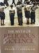
“A FIRE STRONG ENOUGH TO CONSUME THE HOUSE”:, by William T. Cavanaugh,
March 7, 2020

We read:

The State is unlimited in another sense as well, for it demands access to our bodies and our money to fuel its war-making apparatus. The State is implicated in much more than the maintenance of public order. The State is involved in the production, not merely the restraint, of violence. Indeed the modern State depends on violence, war and preparations for war, to maintain the illusion of social integration and the overcoming of contradictions in civil society.
…
The virtues are acquired by disciplined following of virtuous exemplars. Discipline is therefore perhaps best understood as discipleship, whereas the discipline of the State seeks to create disciples of Leviathan, the discipline of the Church seeks to form disciples of Jesus Christ, the Prince of Peace. For this reason our discipline will more often resemble martyrdom than military victory. Oscar Romero, the day before he was martyred, used his authority to order Salvadoran troops to disobey orders to kill. Romero understood that the discipline of Christian discipleship was in fundamental tension with that of the army. He put it this way: “Let it be quite clear that if we are being asked to collaborate with a pseudo peace, a false order, based on repression and fear, we must recall that the only order and the only peace that God wants is one based on truth and justice. Before these alternatives, our choice is clear: We will follow God’s order, not men’s.”
…
To recognize Christ in our sisters and brothers in other lands, the El Salvadors, Panamas and Iraqs of the contemporary scene, is to begin to break the idolatry of the State, and to make visible the Body of Christ in the world. We must cease to think that the only choices open to the Church are either to withdraw into some private or “sectarian” confinement, or to embrace the public debate policed by the State. The Church as Body of Christ transgresses both the lines which separate public from private and the borders of nation-states, thus creating spaces for a different kind of political practice, one which is incapable of being pressed into the service of wars or rumors of wars.

§§§

Jesus Was a Victim of Empire. Acknowledging This Should Transform Christianity, by Christine Mungai, December 16, 2020

The message of the cross is that an unjust killing itself exposes the injustice of the power structure that sanctioned the killing. But the other message of the cross is that unaccountable power never has the last word. God could not allow Jesus to remain in the grave — Sunday morning tells me that even though the night may be long, oppressive systems will one day fall in judgement, and “the kingdoms of this world, will become the kingdom of our Lord Jesus Christ,” as the New Testament asserts.

Instead of using scripture as “a way to baptize our bigotries and consecrate our callousness,” as Jonathan L. Walton argues, I instead would like to invite other Christians to place this Jesus of Nazareth at the center of their faith and practice.

This Jesus was not available to provide spiritual cover for state power, impunity and corruption. This Jesus was not in the business of abetting oppression while preaching patriotism, quiet disobedience, or simplistic appeals to law and order. This Jesus did not even move to Rome to cozy up to the power structures of Empire and “influence” Caesar for good. This Jesus was executed because his life’s work dared to speak of another kingdom and another way of being in the world, where God is on the side of the poor and oppressed and is fighting alongside them for their full humanity.
In the wake of a global pandemic and a year of worldwide protests against racism, police brutality and state-sanctioned murder, imagining this kind of world has never been more urgent.

§§§

Black Toronto residents 20 times more likely to be shot dead by police, study says, by Leyland Cecco, December 10, 2018; May 30, 2020
Black residents in Canada’s largest city are 20 times more likely to be shot dead by the police than white residents, according to a landmark report from the province’s human rights watchdog.

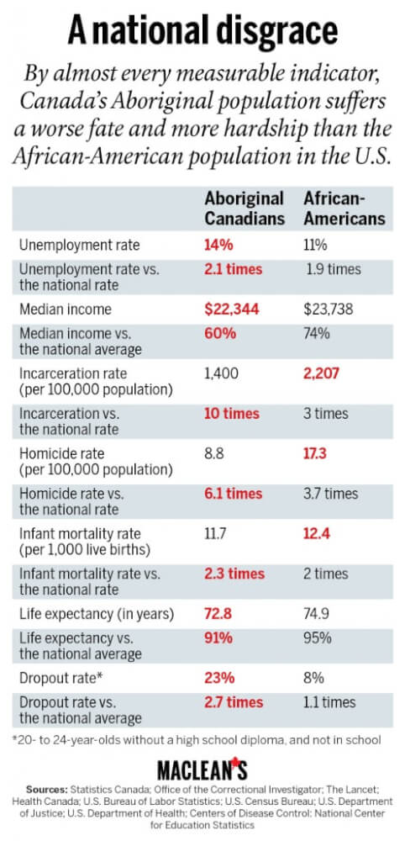
The Ontario Human Rights Commission studied seven years of data surrounding interactions between police and black residents in Toronto, for the report, which found that black residents face disproportionate discrimination and violence at the hands of the police. While black residents make up less than 10% of the city’s population, they accounted for 61% of all cases where police used force that resulted in death and 70% of police shootings that resulted in death.

“When it comes to law enforcement, when it comes to the police, there is an overarching reality of violence that is often a part of the fabric of everyday life for black people in this country,” said Robyn Maynard, author of Policing Black Lives. “I think this data is absolutely damning and reveals something very important.”

Yet I have a close relative who vigorously denies any significant claims of Canadian racism against nonwhites. This is so uninformed and downright bigoted when Canada’s main news magazine, Maclean’s, published this article under the title: “Canada’s race problem? It’s even worse than America’s.” In it we read:

The racial mess in the United States looks pretty grim and is painful to watch. We can be forgiven for being quietly thankful for Canada’s more inclusive society, which has avoided dramas like that in Ferguson, Mo. We are not the only ones to think this. In the recently released Social Progress Index, Canada is ranked second amongst all nations for its tolerance and inclusion.
Unfortunately, the truth is we have a far worse race problem than the United States. We just can’t see it very easily.

Terry Glavin, recently writing in the Ottawa Citizen, mocked the idea that the United States could learn from Canada’s example when it comes to racial harmony. To illustrate his point, he compared the conditions of the African-American community to Canada’s First Nations. If you judge a society by how it treats its most disadvantaged, Glavin found us wanting. Consider the accompanying table. By almost every measurable indicator, the Aboriginal population in Canada is treated worse and lives with more hardship than the African-American population. All these facts tell us one thing: Canada has a race problem, too.

How are we not choking on these numbers? For a country so self-satisfied with its image of progressive tolerance, how is this not a national crisis? Why are governments not falling on this issue?

§§§
The Case for Reparations, by Ta-Nehisi Coates, June 2014; July 11, 2020

This is not surprising. Black families, regardless of income, are significantly less wealthy than white families. The Pew Research Center estimates that white households are worth roughly 20 times as much as black households, and that whereas only 15 percent of whites have zero or negative wealth, more than a third of blacks do. Effectively, the black family in America is working without a safety net. When financial calamity strikes—a medical emergency, divorce, job loss—the fall is precipitous.

...

America begins in black plunder and white democracy, two features that are not contradictory but complementary. “The men who came together to found the independent United States, dedicated to freedom and equality, either held slaves or were willing to join hands with those who did,” the historian Edmund S. Morgan wrote. “None of them felt entirely comfortable about the fact, but neither did they feel responsible for it. Most of them had inherited both their slaves and their attachment to freedom from an earlier generation, and they knew the two were not unconnected.”

…

This “hard usage” originated in a simple fact of the New World—land was boundless but cheap labor was limited. As life spans increased in the colony, the Virginia planters found in the enslaved Africans an even more efficient source of cheap labor. Whereas indentured servants were still legal subjects of the English crown and thus entitled to certain protections, African slaves entered the colonies as aliens. Exempted from the protections of the crown, they became early America’s indispensable working class—fit for maximum exploitation, capable of only minimal resistance.

...

“The two great divisions of society are not the rich and poor, but white and black,” John C. Calhoun, South Carolina’s senior senator, declared on the Senate floor in 1848. “And all the former, the poor as well as the rich, belong to the upper class, and are respected and treated as equals.”

...

By 1840, cotton produced by slave labor constituted 59 percent of the country’s exports. The web of this slave society extended north to the looms of New England, and across the Atlantic to Great Britain, where it powered a great economic transformation and altered the trajectory of world history. “Whoever says Industrial Revolution,” wrote the historian Eric J. Hobsbawm, “says cotton.”
The wealth accorded America by slavery was not just in what the slaves pulled from the land but in the slaves themselves. “In 1860, slaves as an asset were worth more than all of America’s manufacturing, all of the railroads, all of the productive capacity of the United States put together,” the Yale historian David W. Blight has noted. “Slaves were the single largest, by far, financial asset of property in the entire American economy.” The sale of these slaves—“in whose bodies that money congealed,” writes Walter Johnson, a Harvard historian—generated even more ancillary wealth. Loans were taken out for purchase, to be repaid with interest. Insurance policies were drafted against the untimely death of a slave and the loss of potential profits. Slave sales were taxed and notarized. The vending of the black body and the sundering of the black family became an economy unto themselves, estimated to have brought in tens of millions of dollars to antebellum America. In 1860 there were more millionaires per capita in the Mississippi Valley than anywhere else in the country.

...

By the dawn of the Civil War, the enslavement of black America was thought to be so foundational to the country that those who sought to end it were branded heretics worthy of death. Imagine what would happen if a president today came out in favor of taking all American homes from their owners: the reaction might well be violent.

“This country was formed for the white, not for the black man,” John Wilkes Booth wrote, before killing Abraham Lincoln. “And looking upon African slavery from the same standpoint held by those noble framers of our Constitution, I for one have ever considered it one of the greatest blessings (both for themselves and us) that God ever bestowed upon a favored nation.”

...

The American real-estate industry believed segregation to be a moral principle. As late as 1950, the National Association of Real Estate Boards’ code of ethics warned that “a Realtor should never be instrumental in introducing into a neighborhood … any race or nationality, or any individuals whose presence will clearly be detrimental to property values.” A 1943 brochure specified that such potential undesirables might include madams, bootleggers, gangsters—and “a colored man of means who was giving his children a college education and thought they were entitled to live among whites.”
The federal government concurred. It was the Home Owners’ Loan Corporation, not a private trade association, that pioneered the practice of redlining, selectively granting loans and insisting that any property it insured be covered by a restrictive covenant—a clause in the deed forbidding the sale of the property to anyone other than whites. Millions of dollars flowed from tax coffers into segregated white neighborhoods.

...

Liberals today mostly view racism not as an active, distinct evil but as a relative of white poverty and inequality. They ignore the long tradition of this country actively punishing black success—and the elevation of that punishment, in the mid-20th century, to federal policy. President Lyndon Johnson may have noted in his historic civil-rights speech at Howard University in 1965 that “Negro poverty is not white poverty.” But his advisers and their successors were, and still are, loath to craft any policy that recognizes the difference.

...

Yet America was built on the preferential treatment of white people—395 years of it. Vaguely endorsing a cuddly, feel-good diversity does very little to redress this.

Today, progressives are loath to invoke white supremacy as an explanation for anything. On a practical level, the hesitation comes from the dim view the Supreme Court has taken of the reforms of the 1960s. The Voting Rights Act has been gutted. The Fair Housing Act might well be next. Affirmative action is on its last legs. In substituting a broad class struggle for an anti-racist struggle, progressives hope to assemble a coalition by changing the subject.

...

To ignore the fact that one of the oldest republics in the world was erected on a foundation of white supremacy, to pretend that the problems of a dual society are the same as the problems of unregulated capitalism, is to cover the sin of national plunder with the sin of national lying. The lie ignores the fact that reducing American poverty and ending white supremacy are not the same. The lie ignores the fact that closing the “achievement gap” will do nothing to close the “injury gap,” in which black college graduates still suffer higher unemployment rates than white college graduates, and black job applicants without criminal records enjoy roughly the same chance of getting hired as white applicants with criminal records.

…

To celebrate freedom and democracy while forgetting America’s origins in a slavery economy is patriotism à la carte.

Perhaps no statistic better illustrates the enduring legacy of our country’s shameful history of treating black people as sub-citizens, sub-Americans, and sub-humans than the wealth gap. Reparations would seek to close this chasm. But as surely as the creation of the wealth gap required the cooperation of every aspect of the society, bridging it will require the same.

Perhaps after a serious discussion and debate—the kind that HR 40 proposes—we may find that the country can never fully repay African Americans. But we stand to discover much about ourselves in such a discussion—and that is perhaps what scares us. The idea of reparations is frightening not simply because we might lack the ability to pay. The idea of reparations threatens something much deeper—America’s heritage, history, and standing in the world.

…

The early American economy was built on slave labor. The Capitol and the White House were built by slaves. President James K. Polk traded slaves from the Oval Office. The laments about “black pathology,” the criticism of black family structures by pundits and intellectuals, ring hollow in a country whose existence was predicated on the torture of black fathers, on the rape of black mothers, on the sale of black children. An honest assessment of America’s relationship to the black family reveals the country to be not its nurturer but its destroyer.

...

The early American economy was built on slave labor. The Capitol and the White House were built by slaves. President James K. Polk traded slaves from the Oval Office. The laments about “black pathology,” the criticism of black family structures by pundits and intellectuals, ring hollow in a country whose existence was predicated on the torture of black fathers, on the rape of black mothers, on the sale of black children. An honest assessment of America’s relationship to the black family reveals the country to be not its nurturer but its destroyer.

...

Won’t reparations divide us? Not any more than we are already divided. The wealth gap merely puts a number on something we feel but cannot say—that American prosperity was ill-gotten and selective in its distribution. What is needed is an airing of family secrets, a settling with old ghosts. What is needed is a healing of the American psyche and the banishment of white guilt.

What I’m talking about is more than recompense for past injustices—more than a handout, a payoff, hush money, or a reluctant bribe. What I’m talking about is a national reckoning that would lead to spiritual renewal. Reparations would mean the end of scarfing hot dogs on the Fourth of July while denying the facts of our heritage. Reparations would mean the end of yelling “patriotism” while waving a Confederate flag. Reparations would mean a revolution of the American consciousness, a reconciling of our self-image as the great democratizer with the facts of our history.

§§§

In my post, Cornel West Says ‘Neo-Fascist Gangster’ Trump and Neoliberal Democrats Expose America as ‘Failed Social Experiment’, by Jon Queally, staff writer, May 30, 2020, there is an attempt to provide a tiny inkling of information in support of Dr. West’s claim.

The article highlighted in the post above is not merely a “tiny inkling,” it is fruit of painstaking research by a gifted writer about troubled White America. As one reads it, it repeatedly is made plain that the social experiment has not really “failed”; for that would posit a social experiment set out to do one thing, but unsuccessful in the end. Quite the contrary: the “social experiment” by America did not fail in its foundational structures and consequential “tentacleized” permeation of every facet of American life downstream. The System achieved throughout American history exactly what it was designed to do: make the American Dream accessible to one racial group only: Caucasian.

So it is in Canada. Hence, for instance, my: The Great Sumas Lake Heist: A Guilty Little Secret in Plain Sight, December 5, 2021
We read (my opening comments):

This overwhelming tragedy today points to an overwhelming travesty committed a century ago against thousands who had peopled the Sumas Lake area: a Lake that was drained under the noses of–in stark terms, stolen from–the Sumas First Nation.

The current horrific events cast an eerie spotlight on a century-old gargantuan injustice committed by White Settlers. There is no gentle way to state it. Calling it an injustice, a blandly inadequate term, or property theft according to the Criminal Code of Canada, are the only legitimate labels for such an incalculably grotesque high crime.

§§§

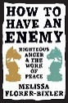
Reparations move us from giving charitably to tackling the roots of economic injustice in the United States[/Canada]. Melissa Florer-Bixler, How to Have an Enemy (p. 161). MennoMedia. Kindle Edition.

Posts of Relevance on my Website:

An Open Letter To Joe Biden
June 11, 2020

- Christchurch, the White Victim Complex and Savage Capitalism
March 17, 2019
• Kipling, the ‘White Man’s Burden,’ and U.S. Imperialism
February 8, 2018

One reads:
Today’s imperialists see Rudyard Kipling’s poem mainly as an attempt to stiffen the spine of the U.S. ruling class of his day in preparation for what he called “the savage wars of peace.” And it is precisely in this way that they now allude to the “white man’s burden” in relation to the twenty-first century. Thus for the Economist magazine the question is simply whether the United States is “prepared to shoulder the white man’s burden across the Middle East.”
As an analyst of as well as a spokesman for imperialism Kipling was head and shoulders above this in the sense that he accurately perceived the looming contradictions of his own time. He knew that the British Empire was overstretched and doomed—even as he struggled to redeem it and to inspire the rising United States to enter the imperial stage alongside it. Only two years before writing “The White Man’s Burden” he wrote his celebrated verse, “Recessional”:

Far-called, our navies melt away;
—On dune and headland sinks the fire;
Lo, all our pomp of yesterday
—Is one with Nineveh and Tyre!
Judge of Nations, spare us yet,
Lest we forget—lest we forget!

The United States is now leading the way into a new phase of imperialism. This will be marked not only by increased conflict between center and periphery—rationalized in the West by veiled and not-so-veiled racism—but also by increased intercapitalist rivalry. This will likely speed up the long-run decline of the American Empire, rather than the reverse. And in this situation a call for a closing of the ranks between those of European extraction (Samuel Huntington’s “clash of civilizations” argument or some substitute) is likely to become more appealing among U.S. and British elites. It should be remembered that Kipling’s “White Man’s Burden” was a call for the joint exploitation of the globe by what [W.E.B.] Du Bois was later to call “the white masters of the world” in the face of the ebbing of British fortunes. At no time, then, should we underestimate the three-fold threat of militarism, imperialism, and racism—or forget that capitalist societies have historically been identified with all three.

Social Problems and Policy During The Puritan Revolution 1640-1660, Routledge; 2022
Edward Gibbon Wakefield, A View of the Art of Colonization: With Present Reference to the British Empire: in Letters Between a Statesman and a Colonist (London, 2019)
According to this analyst, the term “race” emerged in English as early as 1508, just as the African slave trade was taking off. Arguably, English attempts to enslave Japanese in the pivotal seventeenth century contributed to this nation’s self-imposed isolation and emergence in the late nineteenth century as a power bent on upsetting the white supremacy that had strangled Africa. See also Gerald Horne, Race War! White Supremacy and the Japanese Attack on the British Empire, New York: New York University Press, 2003. Of it we read: Japan’s lightning march across Asia during World War II was swift and brutal. Nation after nation fell to Japanese soldiers. How were the Japanese able to justify their occupation of so many Asian nations? And how did they find supporters in countries they subdued and exploited? Race War! delves into submerged and forgotten history to reveal how European racism and colonialism were deftly exploited by the Japanese to create allies among formerly colonized people of color. Through interviews and original archival research on five continents, Gerald Horne shows how race played a key—and hitherto ignored—role in each phase of the war. During the conflict, the Japanese turned white racism on its head portraying the war as a defense against white domination in the Pacific. We learn about the reverse racial hierarchy practiced by the Japanese internment camps, in which whites were placed at the bottom of the totem pole, under the supervision of Chinese, Korean, and Indian guards—an embarrassing example of racial payback that was downplayed by the defeated Japanese and the humiliated Europeans and Euro-Americans. Focusing on the microcosmic example of Hong Kong but ranging from colonial India to New Zealand and the shores of the U.S., Gerald Horne radically retells the story of the war. From racist U.S. propaganda to Black Nationalist open support of Imperial Japan, information about the effect of race on U.S. and British policy is revealed for the first time. This revisionist account of the war draws connections between General Tojo, Malaysian freedom fighters, and Elijah Muhammed of the Nation of Islam and shows how white racism encouraged and enabled Japanese imperialism. In sum, Horne demonstrates that the retreat of white supremacy was not only driven by the impact of the Cold War and the energized militancy of Africans and African-Americans but by the impact of the Pacific War as well, as a chastened U.S. and U.K. moved vigorously after this conflict to remove the conditions that made Japan’s success possible.
The fuller quote goes: I cannot accept your canon that we are to judge Pope and King unlike other men, with a favourable presumption that they did no wrong. If there is any presumption it is the other way against holders of power, increasing as the power increases. Historic responsibility has to make up for the want of legal responsibility. Power tends to corrupt and absolute power corrupts absolutely. Great men are almost always bad men, even when they exercise influence and not authority: still more when you superadd the tendency or the certainty of corruption by authority. There is no worse heresy than that the office sanctifies the holder of it. That is the point at which the negation of Catholicism and the negation of Liberalism meet and keep high festival, and the end learns to justify the means. You would hang a man of no position, like Ravaillac; but if what one hears is true, then Elizabeth asked the gaoler to murder Mary, and William III ordered his Scots’ minister to extirpate a clan. Here are the greater names coupled with the greater crimes. You would spare these criminals, for some mysterious reason. I would hang them, higher than Haman, for reasons of quite obvious justice; still more, still higher, for the sake of historical science. (Emphasis added)–Lord Acton writes to Anglican Bishop Creighton that the same moral standards should be applied to all men, political and religious leaders included, especially since “Power tends to corrupt and absolute power corrupts absolutely” (1887)
Archbishop Oscar Romero, “The Church Defender of Human Dignity” in A Martyr’s Message of Hope (Kansas City Celebration Books, 1981), ρ 161. The relevant part of his sermon on March 23, 1980 reads as follows: I would like to issue a special entreaty to the members of the army, and specifically to the ranks of the National Guard, the police and the military. Brothers and sisters, you are our own people, you kill your own fellow peasants. Someone’s order to kill should not prevail, rather, what ought to prevail is the law of God that says, ‘Do not kill.’ No soldier is obliged to obey an order against the law of God, no one has to fulfill an immoral law. Why, in the name of God, and in the name of this suffering people whose cries rise up to the heavens every day in greater tumult, I implore them, I beg them, I order them, in the name of God: Cease the repression.
See Kipling’s poem: Take up the White Man’s burden — Send forth the best ye breed — Go bind your sons to exile To serve your captives’ need; To wait in heavy harness, On fluttered folk and wild — Your new-caught, sullen peoples, Half-devil and half-child. Take up the White Man’s burden — In patience to abide, To veil the threat of terror And check the show of pride; By open speech and simple, An hundred times made plain To seek another’s profit, And work another’s gain. Take up the White Man’s burden — The savage wars of peace — Fill full the mouth of Famine And bid the sickness cease; And when your goal is nearest The end for others sought, Watch sloth and heathen Folly Bring all your hopes to nought. Take up the White Man’s burden — No tawdry rule of kings, But toil of serf and sweeper — The tale of common things. The ports ye shall not enter, The roads ye shall not tread, Go make them with your living, And mark them with your dead. Take up the White Man’s burden — And reap his old reward: The blame of those ye better, The hate of those ye guard — The cry of hosts ye humour (Ah, slowly!) toward the light: — “Why brought he us from bondage, Our loved Egyptian night?” Take up the White Man’s burden — Ye dare not stoop to less — Nor call too loud on Freedom To cloak your weariness; By all ye cry or whisper, By all ye leave or do, The silent, sullen peoples Shall weigh your gods and you. Take up the White Man’s burden — Have done with childish days — The lightly profferred laurel, The easy, ungrudged praise. Comes now, to search your manhood Through all the thankless years Cold, edged with dear-bought wisdom, The judgment of your peers! Source: Rudyard Kipling, “The White Man’s Burden: The United States & The Philippine Islands, 1899.” Rudyard Kipling’s Verse: Definitive Edition (Garden City, New York: Doubleday, 1929).
This call upon white élites to divide the world evoked a response beyond Britain and the United States. The admiration of Kipling among the ruling classes at the center of the capitalist world was more general. As Hobsbawm tells us: When the writer Rudyard Kipling, the bard of the Indian empire, was believed to be dying of pneumonia in 1899, not only the British and the Americans grieved—Kipling had just addressed a poem on ‘The White Man’s Burden’ to the USA on its responsibilities in the Philippines—but the Emperor of Germany sent a telegram. Eric Hobsbawm, The Age of Empire (New York: Vintage, 1987), p. 82.

